  
ESCUELA SUPERIOR   
PÓLITECNICA DEL LITORAL  
  
**WORKSHOP ABOUT EMPIRICAL SOFTWARE TESTING**  
  
**AUTORES:**

* AGUILAR MORA OSWALDO
* BERMUDEZ MOREIRA KAREN
* BERNAL MOREIRA GUILLERMO
* ORTIZ HOLGUIN EDUARDO
* WONG PAVON HUGO

**SUBJECT:** ING. SOFTWARE II  
**TUTOR:** DR. MERA CARLOS  
**DEADLINE:** 2020/06/11

1. **Abstract**

This document contains the technical report corresponding to the first group workshop called **"WORKSHOP ABOUT EMPIRICAL SOFTWARE TESTING"** of **GROUP#4** belonging to the **SOFTWARE II ENGINEERING** course of **2020-PAO I**.

The report contains a description of the workshop, the pseudocode, the testing approach, the JAVA implementation and the test result.

1. **Description**

The triangle problem is presented together with a pseudocode that provides a solution to the identification of the type of triangle, or if the values ​​entered do not form this figure, with their respective validations, in this workshop it is requested to implement the pseudocode, design the cases of tests deemed necessary and finally execute the test cases.

* 1. **Triangle problem**

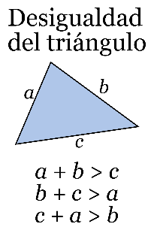It is one of the most used problems for teaching **software tests**, it consists of a program that must take as input three integer numerical values ​​that correspond to the sides of a triangle, must evaluate the necessary conditions and finally determine if the entered values ​​correspond to a **scalene** **triangle**, an **equilateral** triangle, an **isosceles** triangle, or ultimately the values ​​do not form a triangle.

To determine it, there are the following conditions:

* The entered values ​​must be in the range of [1,200].
* Values ​​must comply with triangular inequality.
* The equality of the sides determines whether they are equilateral, scalene or isosceles.

**Figure 1.- Triangular Inequality**

* 1. **Implementation**

It is requested to carry out the implementation using as a JAVA language additionally to use some tool to carry out the tests and the collaborative development tool Git.

1. **Pseudocode**

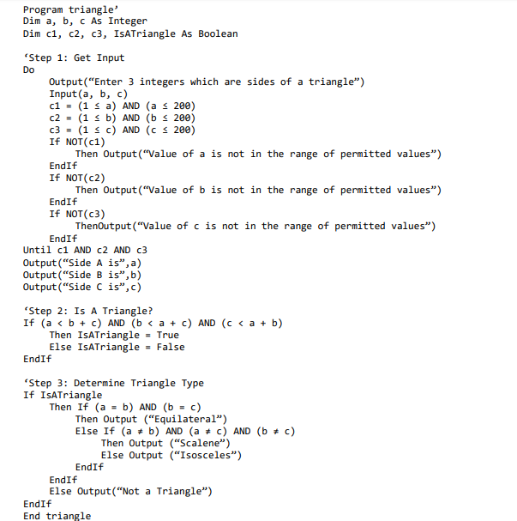

**Figure 2.- Triangle Problem Pseudocode**

1. **Design of Test Cases**

It has been decided to divide the tests into the following categories:

* Data Type Tests
* Range of Values Tests
* Results Tests
  1. **Data Type Tests**

These tests will evaluate the **robustness** of the program, that is, if it does not crash due to the values ​​entered and if it notifies the user of the error. They will be tested with non-integer values ​​either **floating** **point** or text **strings**.

* 1. **Range of Values Tests**

In these tests the correct validation of the variables will be evaluated, if they are in the designated range between **1** and **200**, if they show the correct messages.

* 1. **Results Tests**

In these tests, the final results will be evaluated after passing the previous validations, correct values ​​will be used, and the results will be verified among the 4 possible cases **(Equilateral, Scalene, Isosceles, Non-Triangle).**

* 1. **Detail of test cases**

|  |  |  |  |  |  |
| --- | --- | --- | --- | --- | --- |
| **# Case** | **Commentary** | **a** | **b** | **c** | **Result** |
| **Data Type Tests** | | | | | |
| **1** | String 1 | 30 | b | 2 | **Error 1** |
| **2** | String 2 | sk | 1 | Sd | **Error 1** |
| **3** | Floating point 1 | 21 | 5 | 3,4 | **Error 1** |
| **4** | Floating point 2 | 5,4 | 2,1 | 199,2 | **Error 1** |
| **5** | Mix | 4 | 7,5 | abc | **Error 1** |
| **Range of Values Tests** | | | | | |
| **6** | Exceedance a | 274 | 12 | 97 | **Error 2** |
| **7** | Exceedance b | 76 | 599 | 3 | **Error 2** |
| **8** | Exceedance c | 55 | 55 | 201 | **Error 2** |
| **9** | Insufficient a | 0 | 2 | 2 | **Error 2** |
| **10** | Insufficient b | 12 | -45 | 90 | **Error 2** |
| **11** | Insufficient c | 124 | 125 | -1 | **Error 2** |
| **12** | Mix 1 | 156 | 500 | -12 | **Error 2** |
| **13** | Mix 2 | 0 | -999 | 999 | **Error 2** |
| **Results Tests** | | | | | |
| **14** | Equilateral 1 | 5 | 5 | 5 | Equilateral |
| **15** | Equilateral 2 | 200 | 200 | 200 | Equilateral |
| **16** | Scalene 1 | 5 | 3 | 7 | Scalene |
| **17** | Scalene 2 | 70 | 120 | 170 | Scalene |
| **18** | Isosceles 1 | 6 | 3 | 6 | Isosceles |
| **19** | Isosceles 2 | 132 | 132 | 140 | Isosceles |
| **20** | No triangle 1 | 6 | 13 | 6 | No triangle |
| **21** | No triangle 2 | 40 | 24 | 199 | No triangle |
| **22** | No triangle 3 | 1 | 2 | 3 | No triangle |

1. **Source Code**
   1. **Repository**

**Github** was used as a collaboration tool for the development of the workshop, the link is:

* <https://github.com/kbermude/Taller1_Software>
  1. **Development Considerations**

For the development of the activity and its implementation, the following points were considered:

* **Eclipse** was used as Java IDE.
* The **jUnit** tool was used for the tests.

1. **Tests and Results**

|  |  |  |  |  |  |  |
| --- | --- | --- | --- | --- | --- | --- |
| **# Case** | **Commentary** | **a** | **b** | **c** | **Theorycal Result** | **Test  Result** |
| **Data Type Tests** | | | | | | |
| **1** | String 1 | 30 | b | 2 | **Error 1** | **System Crash** |
| **2** | String 2 | sk | 1 | Sd | **Error 1** | **System Crash** |
| **3** | Floating point 1 | 21 | 5 | 3,4 | **Error 1** | **System Crash** |
| **4** | Floating point 2 | 5,4 | 2,1 | 199,2 | **Error 1** | **System Crash** |
| **5** | Mix | 4 | 7,5 | abc | **Error 1** | **System Crash** |
| **Range of Values Tests** | | | | | | |
| **6** | Exceedance a | 274 | 12 | 97 | **Error 2** | **Error 2** |
| **7** | Exceedance b | 76 | 599 | 3 | **Error 2** | **Error 2** |
| **8** | Exceedance c | 55 | 55 | 201 | **Error 2** | **Error 2** |
| **9** | Insufficient a | 0 | 2 | 2 | **Error 2** | **Error 2** |
| **10** | Insufficient b | 12 | -45 | 90 | **Error 2** | **Error 2** |
| **11** | Insufficient c | 124 | 125 | -1 | **Error 2** | **Error 2** |
| **12** | Mix 1 | 156 | 500 | -12 | **Error 2** | **Error 2** |
| **13** | Mix 2 | 0 | -999 | 999 | **Error 2** | **Error 2** |
| **Results Tests** | | | | | | |
| **14** | Equilateral 1 | 5 | 5 | 5 | **Equilateral** | **Equilateral** |
| **15** | Equilateral 2 | 200 | 200 | 200 | **Equilateral** | **Equilateral** |
| **16** | Scalene 1 | 5 | 3 | 7 | **Scalene** | **Scalene** |
| **17** | Scalene 2 | 70 | 120 | 170 | **Scalene** | **Scalene** |
| **18** | Isosceles 1 | 5 | 2 | 5 | **Isosceles** | **Isosceles** |
| **19** | Isosceles 2 | 132 | 132 | 140 | **Isosceles** | **Isosceles** |
| **20** | No triangle 1 | 6 | 13 | 6 | **No triangle** | **No triangle** |
| **21** | No triangle 2 | 40 | 24 | 199 | **No triangle** | **No triangle** |
| **22** | No triangle 3 | 1 | 2 | 3 | **No triangle** | **No triangle** |

1. **Evidence**

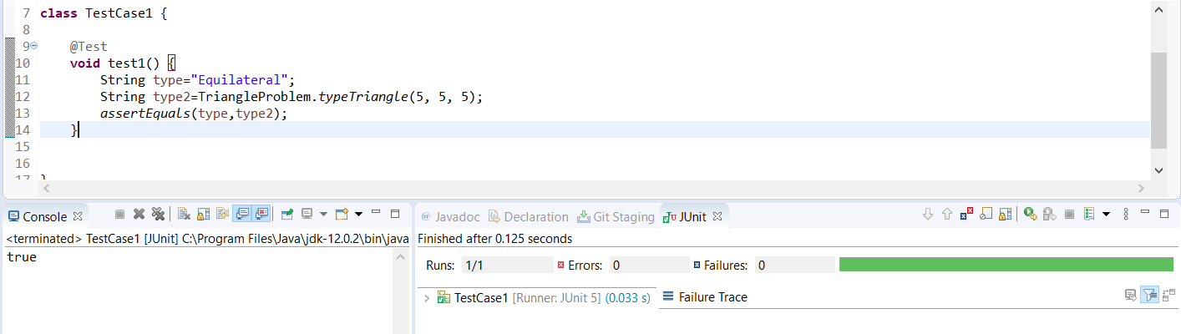

**Figure 3.- Test #14 (5,5,5)**

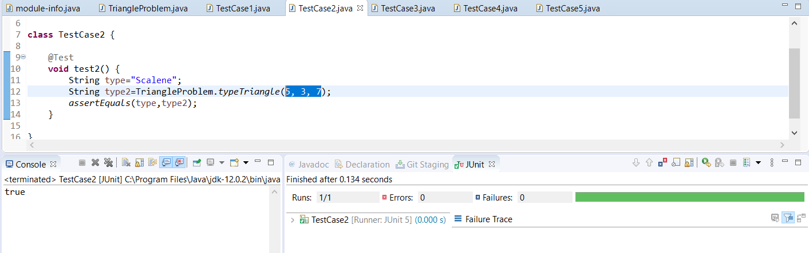

**Figure 4.- Test #16 (5,3,7)**

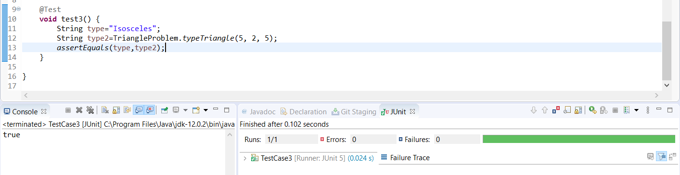

**Figure 5.- Test #18 (5,2,5)**

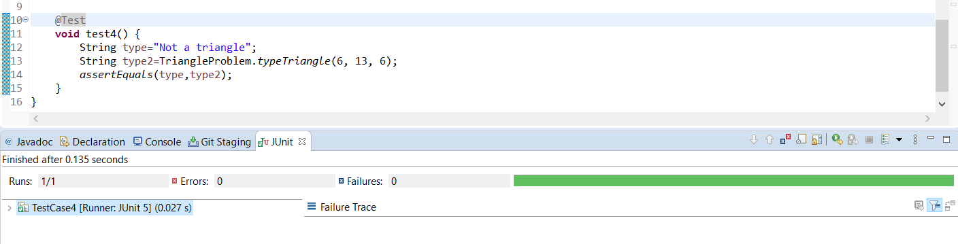

**Figure 6.- Test #20 (6,13,6)**

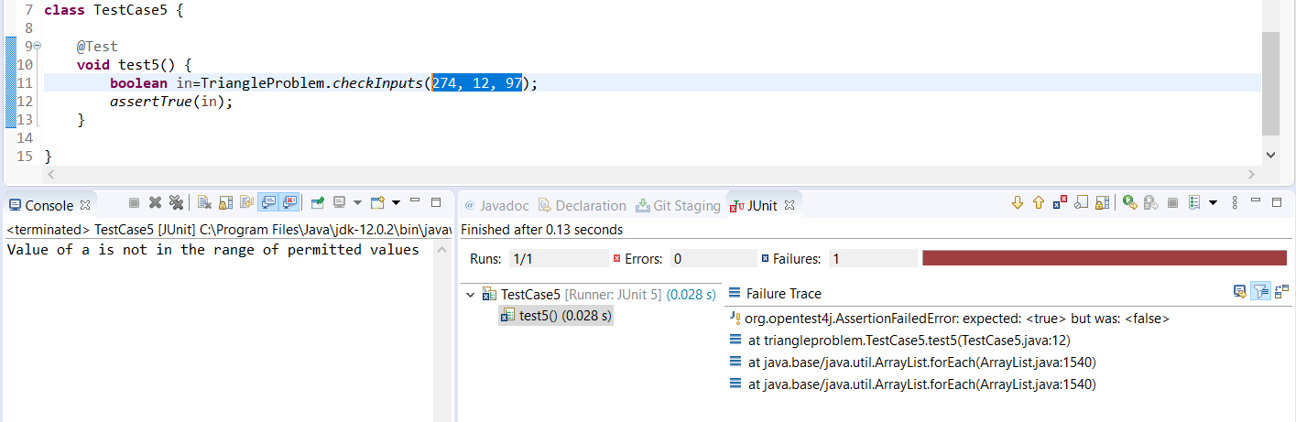

**Figure 7.- Test #6 (274,12,97)**

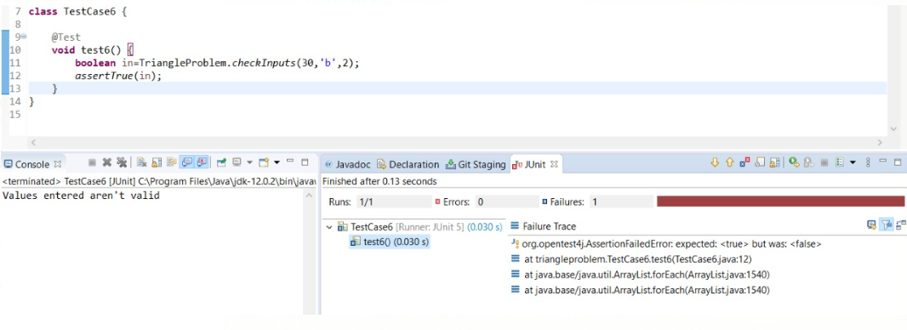

**Figure 8.- Test #1 (30,'b',2)**

1. **Conclusions**

* The program pass **17/22** tests.
* The **5** **faults** are in the first group of tests **“Data type Tests”** , the program input as defined by integer values, if we pass other data type the program present a system crash.
* The program is correctly implemented in input range, in case that input is over or under the range the system presents a message predefined.
* The program presents the correct result in case that the input values correspond to equilateral, scalene or isosceles triangle.
* The program presents the correct message in case that the input values do not correspond to a triangle.
* **JUnit** is a useful tool to test the software.